
Department of Mechanical and Industrial Engineering
Mechanical Engineering
Course Number | MEC713
Course Title | Project Management
Semester/Year | Fall/2023
Professor name | Dr. Sajad Saeedi
T.A name | Feze Golshani Gharie Ali

Assignment No. |  | 3

Submission Date | 9 Nov, 2023
Due Date | 9 November, 2023

Student Name | Student ID (xxxx1234) | Signature*
Farris Hamid | xxxx34692 | 
(Note: Remove the first 4 digits from your student ID)
*By signing above you attest that you have contributed to this submission and confirm that all work you have contributed to this submission is your own work. Any suspicion of copying or plagiarism in this work will result in an investigation of Academic Misconduct and may result in a “0” on the work, an “F” in the course, or possibly more severe penalties, as well as a Disciplinary Notice on your academic record under the Student Code of Academic Conduct, which can be found online at: http://www.ryerson.ca/senate/policies/pol60.pdf.

Solve the following problems and upload the file of solutions in the D2L. You may type the solutions in Microsoft Word and upload the file, or you may scan your solutions by scanner and upload the file in the D2L (due date: Thursday, November 9, 11:59 am).
1.
a. What is Primavera software?
- Primavera is a project management software application by Oracle Corporation.
- Widely used for project management in various industries.
- Known for its comprehensive features that help project managers plan, manage, and execute projects of varying sizes and complexities.

b. What are the advantages and disadvantages of this software compared to Microsoft Project?

Advantages:
- Scalability: Primavera is particularly well-suited for managing large, complex projects and portfolios. It can handle thousands of activities and resources, making it more suitable for enterprises with intricate project management needs.
- Features: Primavera offers more advanced features for project management, including risk analysis, cost management, resource management, and earned value management.
- Integration: As part of the Oracle ecosystem, Primavera integrates well with other Oracle products, making it suitable for organizations that use multiple Oracle solutions.

Disadvantages:
- Complexity: The complexity of Primavera can be a disadvantage to users who do not require advanced features.
- Cost: Generally more expensive than Microsoft Project, both in terms of licensing and training employees.

c. Which one (Primavera or Microsoft Project) is more expensive for the users?
In terms of cost, Primavera is generally more expensive than Microsoft Project. The exact cost can vary significantly depending on factors such as the number of users, the specific version of the software, the level of support, and any additional services required for implementation and training. However, Primavera is considered an enterprise-level solution with a price point to match, while Microsoft Project offers more affordable options for smaller organizations and projects.

2. The yearly demand for a seasonal, profitable item follows the distribution:
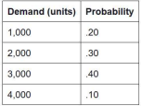
A manufacturer is considering launching a project to produce this item and could produce it by one of three methods:

- Method a. Use existing tools at a cost of $6 per unit.
- Method b. Buy cheap, special equipment for $1,000. The value of the equipment at the end of the year (salvage value) is zero. The cost would be reduced to $3 per unit.
- Method c. Buy high-quality, special equipment for $10,000 that can be depreciated over four years (one fourth of the cost each year). The cost with this equipment would be only $2 per unit.
Set up this project as a decision tree to find whether the manufacturer should approve this project, and if so, which method of production to use to maximize profit.
Hint: Compare total annual costs. Assume that production must meet all demand; each unit demanded and sold means more profit. (20 points)

Expected Value using Decision Tree Method:

The expected value is the combination of the probability of each node with its result.

In this problem, there are 4 demands:
- 1000
- 2000
- 3000
- 4000

To obtain the EV value using the decision tree method, we calculate the sum of the product of payoff & probability.

$Expected Value = (0.2×1000)+(0.3×2000)+(0.4×3000)+(0.1×4000)$

$Expected Value=2400$

Option A
- Total tools cost $6.
- Total tools cost for 2400 units for year 1 is $14,400
- Total tools cost for 2400 units for year 2 is $14,400
- Total tools cost for 2400 units for year 3 is $14,400
- Total tools cost for 2400 units for year 4 is $14,400
- For four years the total cost is $ 57,600.

Option B
- Buy a special equipment for $1000
- The total tool cost is reduced to $3
- Total tools cost for 2400 units is $7,200
- Cost incurred = 7200 + 1000 = 8200
- Total cost incurred for year 1 is $ 8,200.
- Total cost incurred for year 2 is $ 8,200.
- Total cost incurred for year 3 is $ 8,200.
- Total cost incurred for year 4 is $ 8,200.
- For four years the total cost is $32,800.

Option C
- Buy a high quality special equipment for $10,000
- The total tool cost is reduced to $2
- Salvage value at year 1 = 7500
- Salvage value at year 2 = 5,000
- Salvage Value at Year 3 = 2,500
- Salvage Value at year 4 = 0
- Year 1 cost incurred = 10,000 + (2400*2) = 14,800
- Year 2 cost incurred = (2400*2) = 4800
- Year 3 cost incurred = (2400*2) = 4800
- Year 4 cost incurred = 2400 *2 = 4800
- Total cost incurred for 4 years = $ 29,200

Option C is the best choice considering the 4 years cost.

3.
a. What is “slack” and why is it important in projects?

Slack in project management refers to the amount of time that a task within the project can be delayed without causing a delay to the projects or else schedule. Slack is an essential concept in project management because it helps project managers and teams to understand the flexibility for managing a project schedule.

b. How is the critical path determined? (20 points)

The critical path in project management is the sequence of tasks or activities that determine the project's earliest completion date. It is the longest path through the project network diagram, where the total duration of the activities on this path is equal to the minimum possible project duration. The critical path is determined by the process called the Critical Path Method (CPM).
- Define project activities
- Construct network diagram
- Calculate task duration
- identify the dependencies
- Calculate total float/slack
- identify the critical path
  - Sequence of tasks with zero total float.
  - These are the tasks that, if delayed the entire project will be delayed.
- Determine the project duration from the critical path.

4. (20 points)
Given the following network,
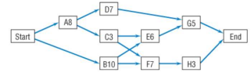

a. What is the critical path?
- A-D-G = 8+7+5 = 20
- A-C-E-G = 8+3+6+5 = 22
- A-C-F-H = 8+3+7+3 = 21
- B-E-G = 10+6+5 = 21
- B-F-H = 10+7+3 = 20

The critical path is the path with the longest duration. Therefore, the critical path is: A-C-E-G.

b. How long will it take to complete this project?

The duration of the project is 22 days.

c. Can activity B be delayed without delaying the completion of the project? If so, how many days?

- Activity B can be delayed since it is not part of the critical path.
- The days it could be delayed is:
  - 22-21 = 1 day

5. (20 points)
Given the estimated activity times below and the network in Exercise 4,
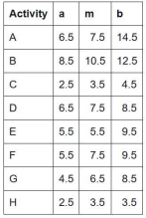
What is the probability that the project will be completed within (based on the path with the longest expected time):
a. 21 days?
b. 22 days?
c. 25 days?

The calculation is below for the solution:
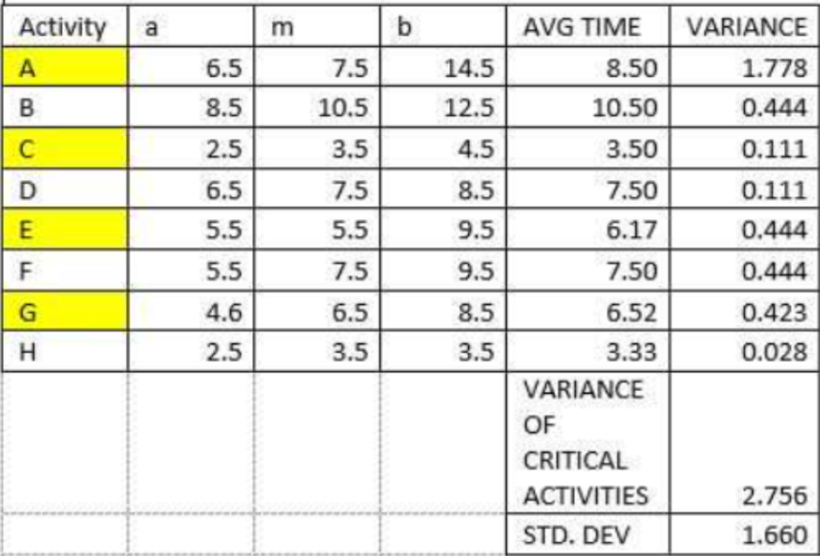

- Probability that the project will be completed within 21 days:
  - P = NORMDIST(21,24.667,1.667, TRUE) = 1.39%

- Probability that the project will be completed within 22 days:
  - P = NORMDIST(22,24.667,1.667, TRUE) = 5.48%

- Probability that the project will be completed within 25 days:
  - P = NORMDIST(25,24.667,1.667, TRUE) = 57.93%

